**KOF Box 2021**

Changes

* The hurt box is green for both characters on the screen. The throw box is blue and located under the collision box.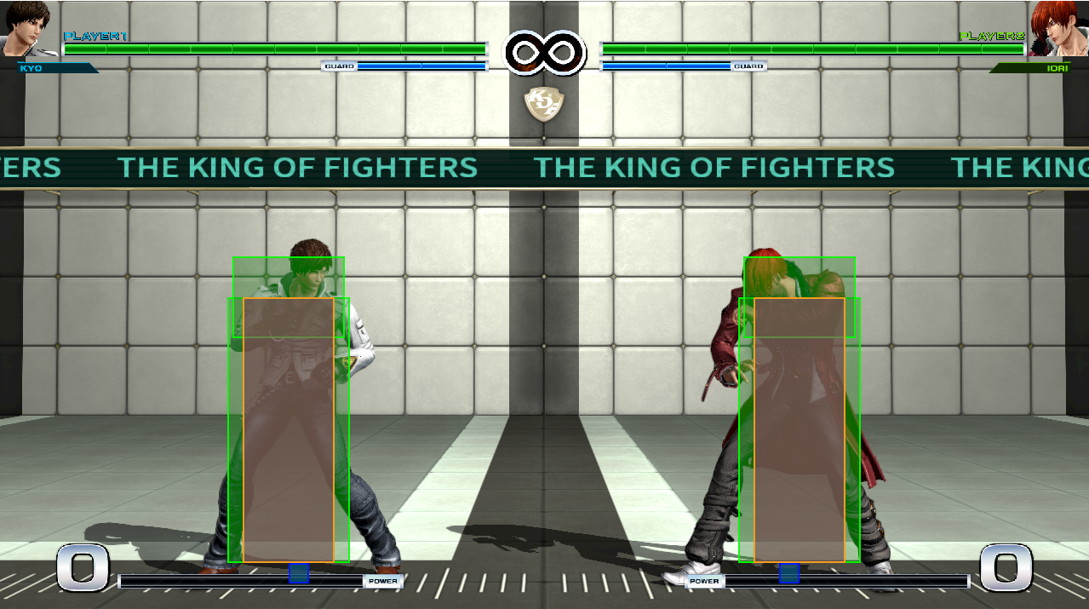
* Guard Box has a black overlay with a black outline.

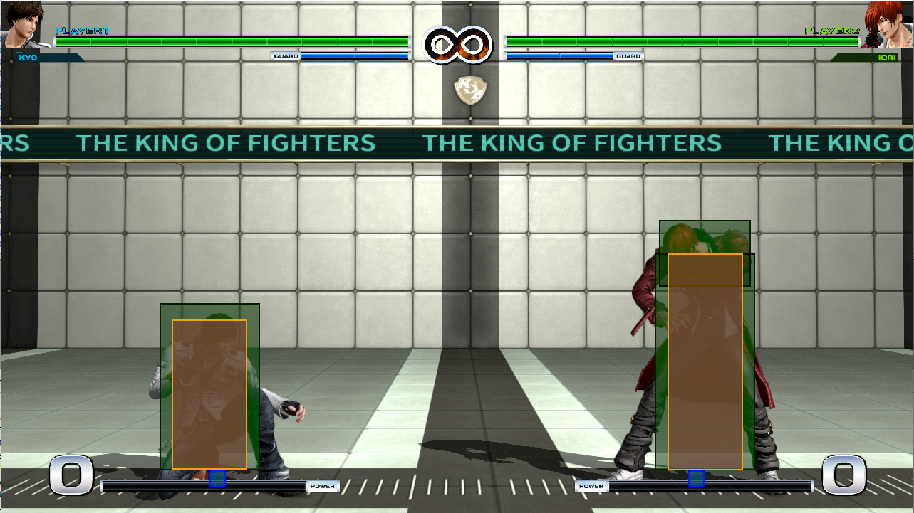

* Throw box in display.

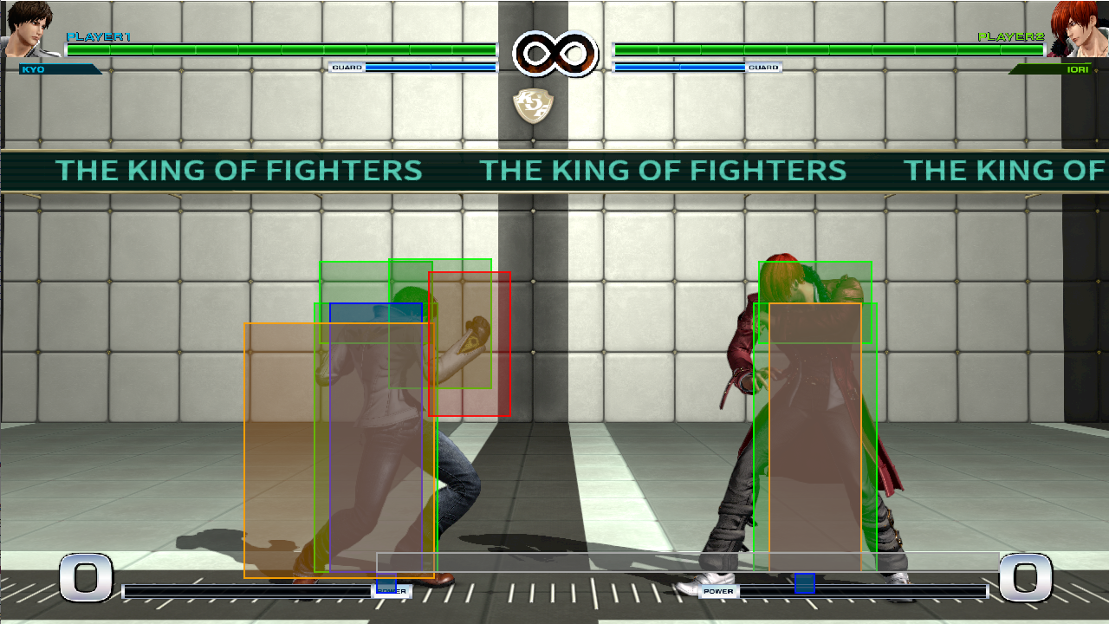

* The throw box during rolls and OTG state is now blue as well.

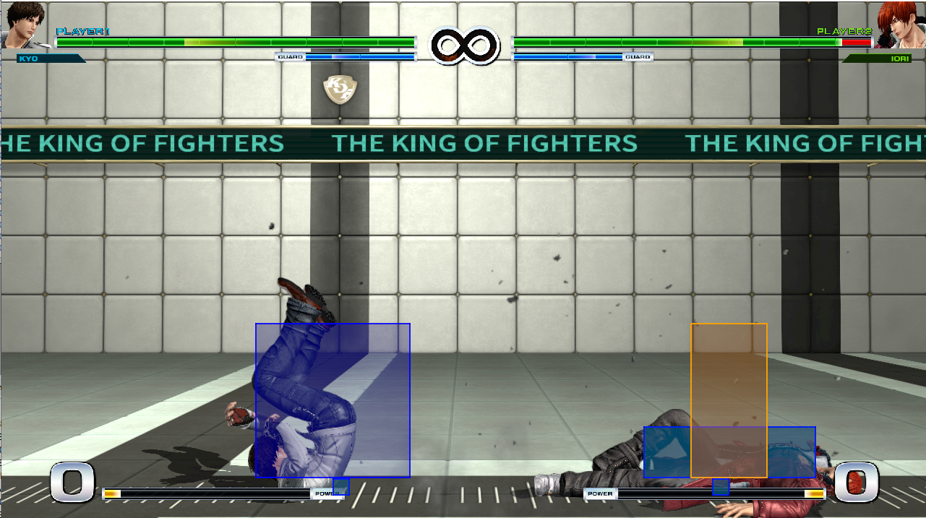

* Throw vulnerable (Grayish Orange box on the left) vs Throw invincible (Orange box on the right)

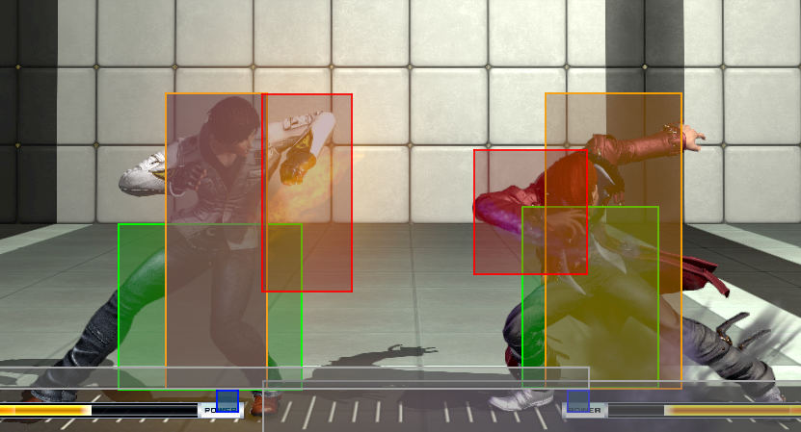

* The Auto Guard box has a light overlay with a light blue outline.

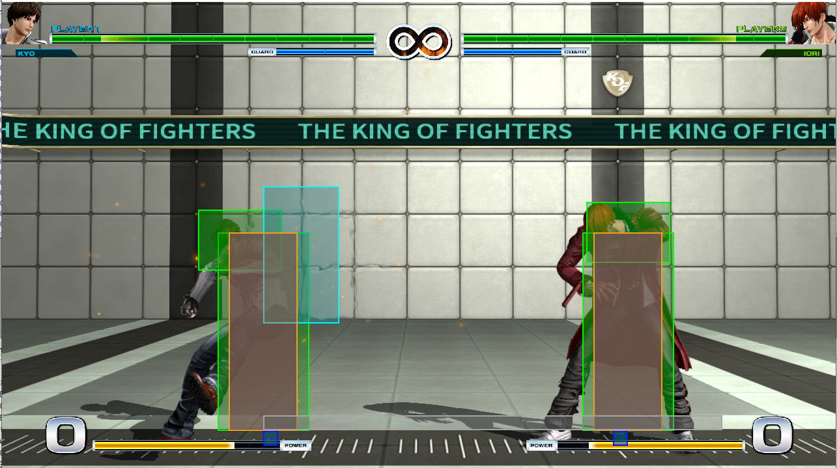

* The physical Projectile Collision box has a yellow overlay with a yellow outline.

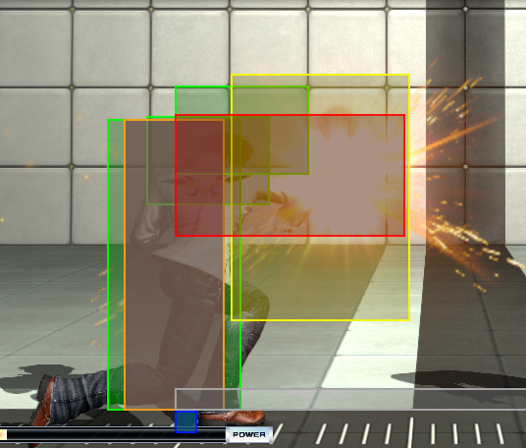

* The physical Projectile Reflector box has a purple overlay with a purple outline.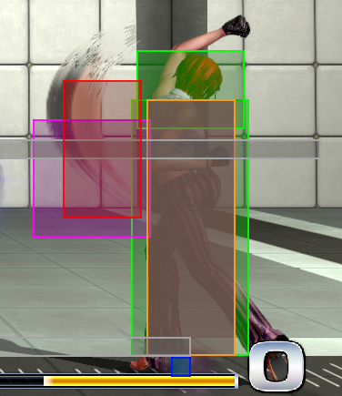
* The projectile Reflector box has a pink overlay with a pink outline.

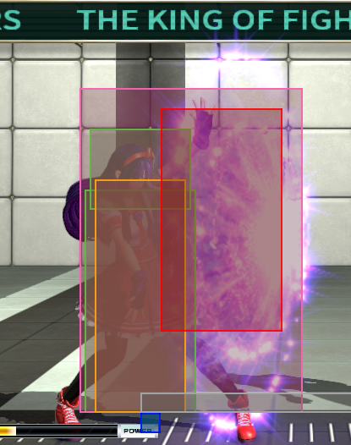

* The collision box, hitbox, and projectile collision boxes are still the same as before.
  + Hitbox: Red outline and red overlay.
  + Projectile Collision Box: White Outline and clear overlay
  + Proximity Box: Grey outline and gray overlay
  + Collision Box: Orange outline and orange overlay.

Credit to Loïc *WydD* Petit (<https://twitter.com/WydD>) for creating the original KOF Box at <https://github.com/WydD/kofbox/releases>.

Contact: Amedo310 (<https://twitter.com/Amedo310>) for any suggestions or issues for the KOF Box 2021 version.

Hitbox Viewer Direct Link: <https://drive.google.com/file/d/1sC9ORNw8wf2vBpMs_cJ611kI_C7Hi6SC/view?usp=sharing>